Step 1 : Select the Price Books tab

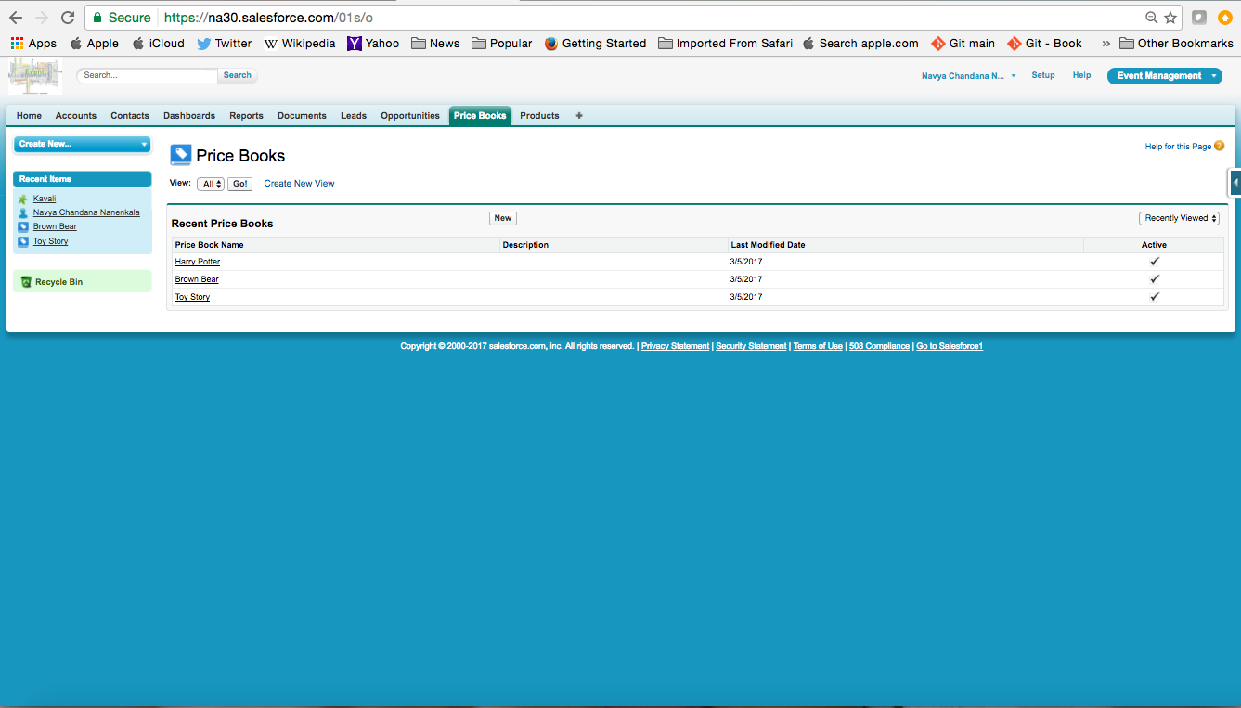

Step 2 : Create a new price book. Click New

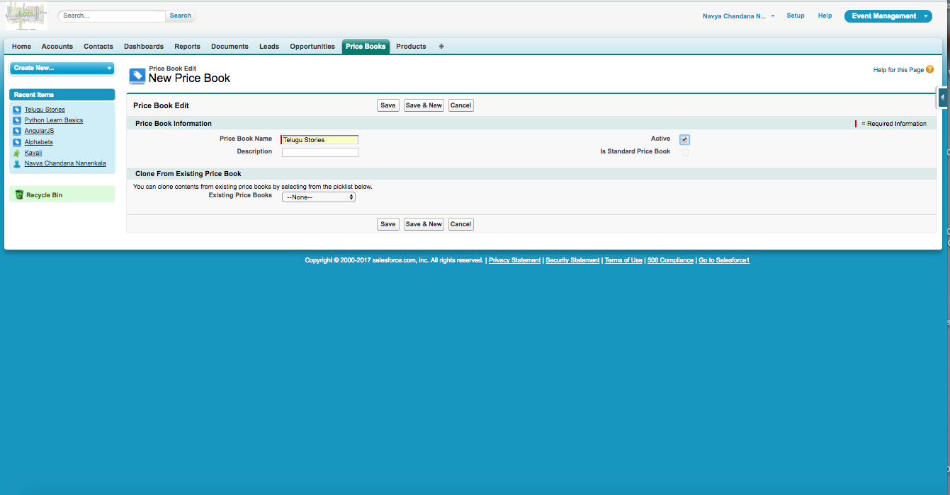

Click Save

Step 3 : Now we need to add Products. Click on Add in Products

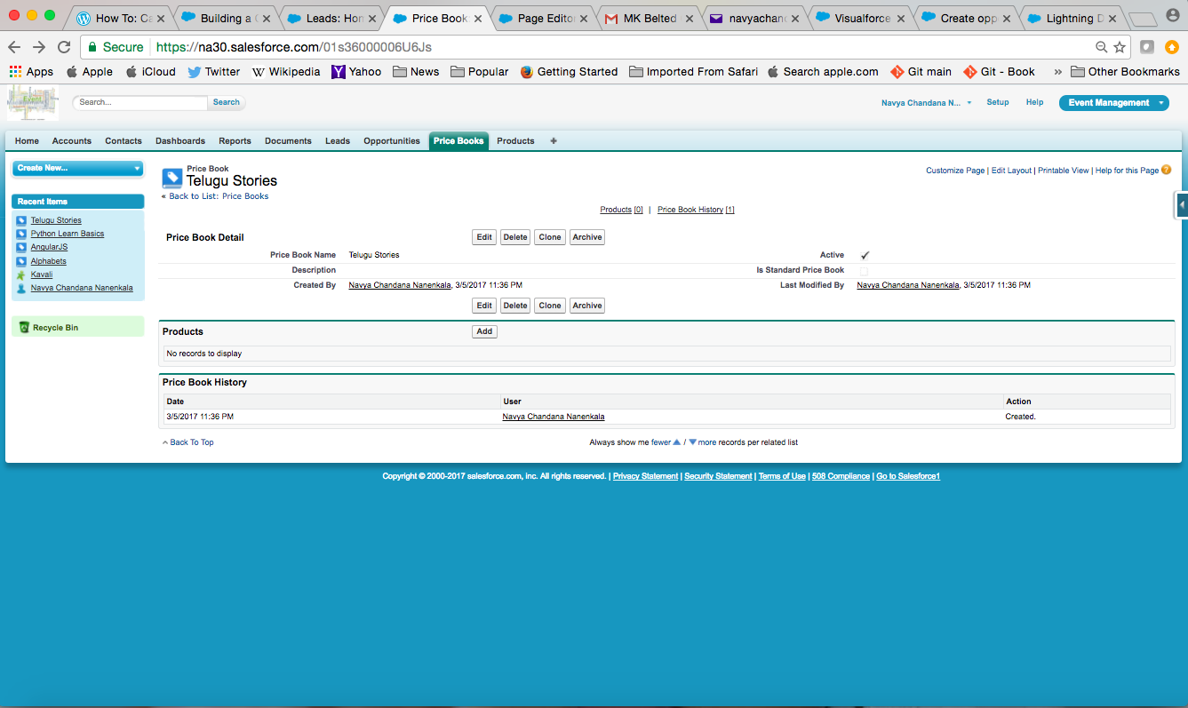

Step 4 : Select the products which we want to add to the Price Books. After choosing the products click on Select.

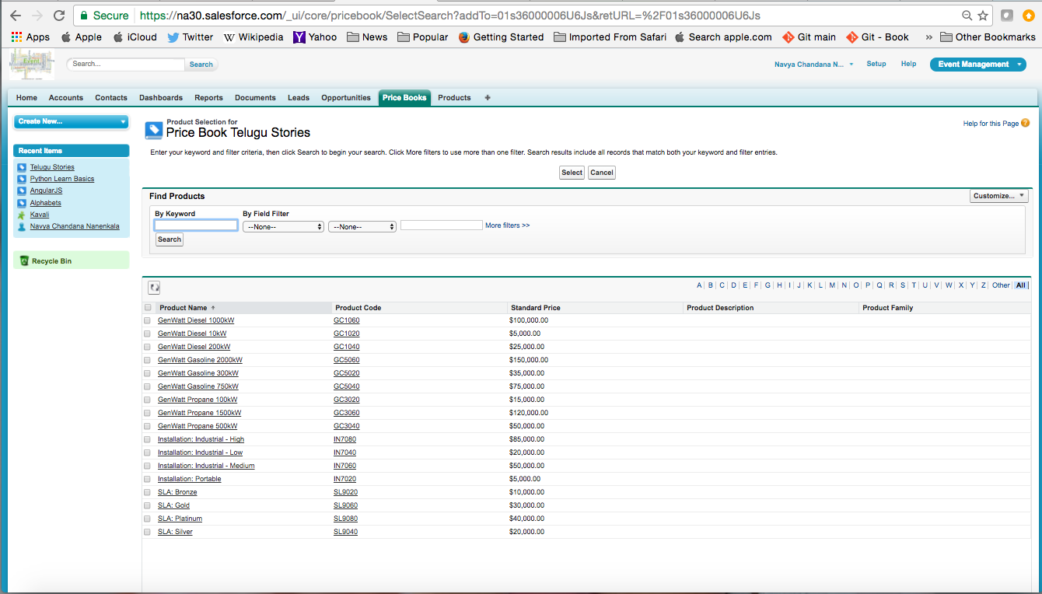

Step 5 : After clicking Select this page appears where we need to add List price and Click Save

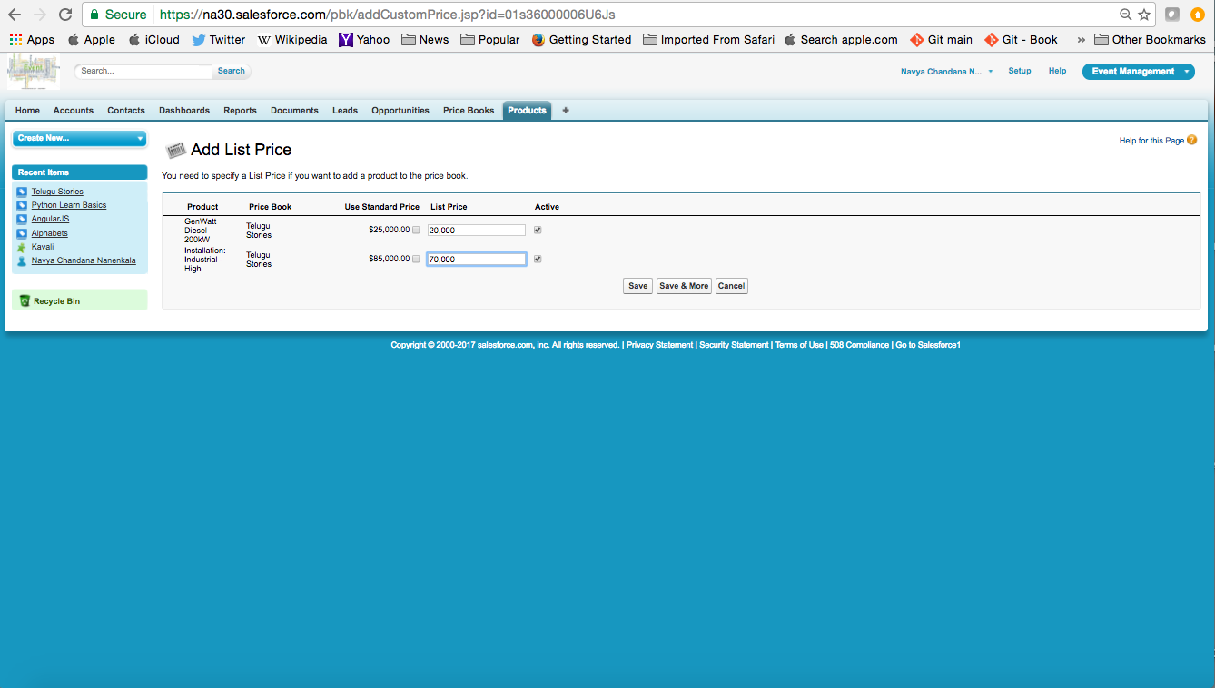

Step 6 : Now we see that the products are added to Price Book

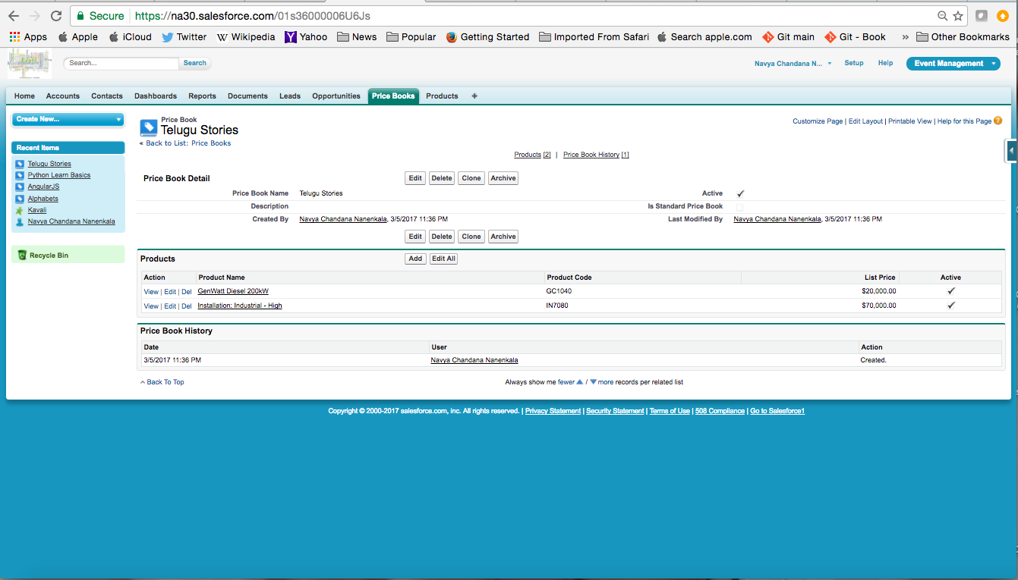

Step 7 : Goto Setup> Quick find> Visualforce Pages

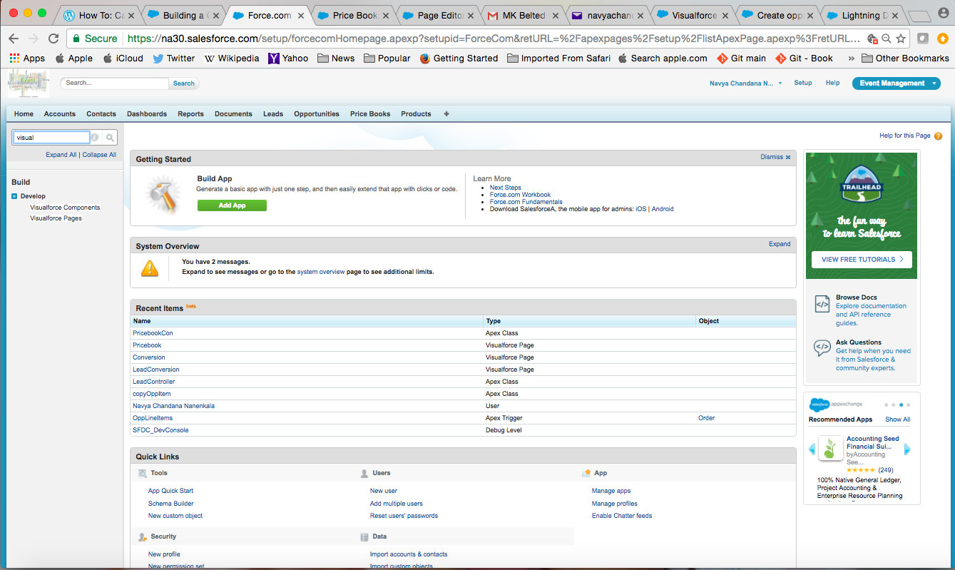

Step 8 : Visualforce Page appears.

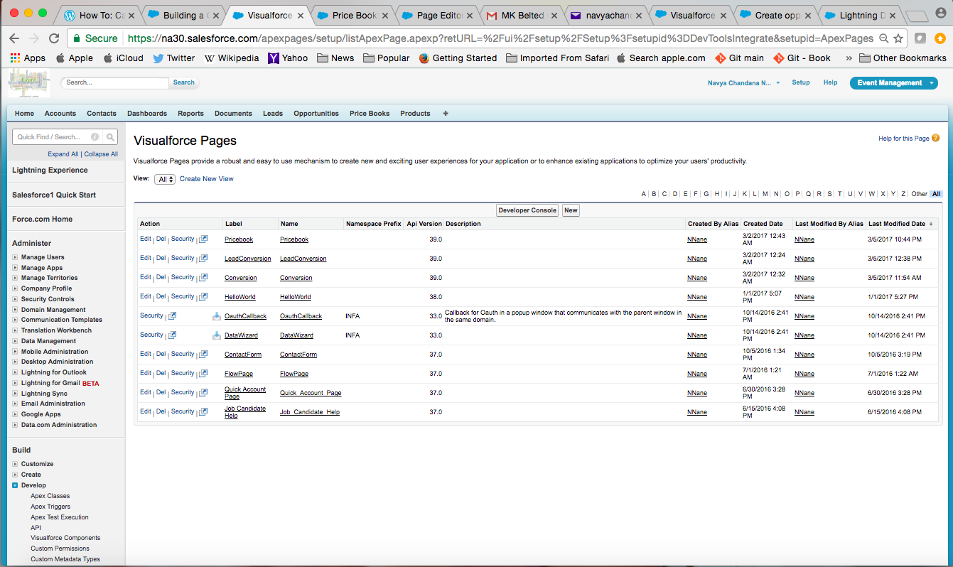

Step 9 : Select Pricebook.vfp Visualforce Page

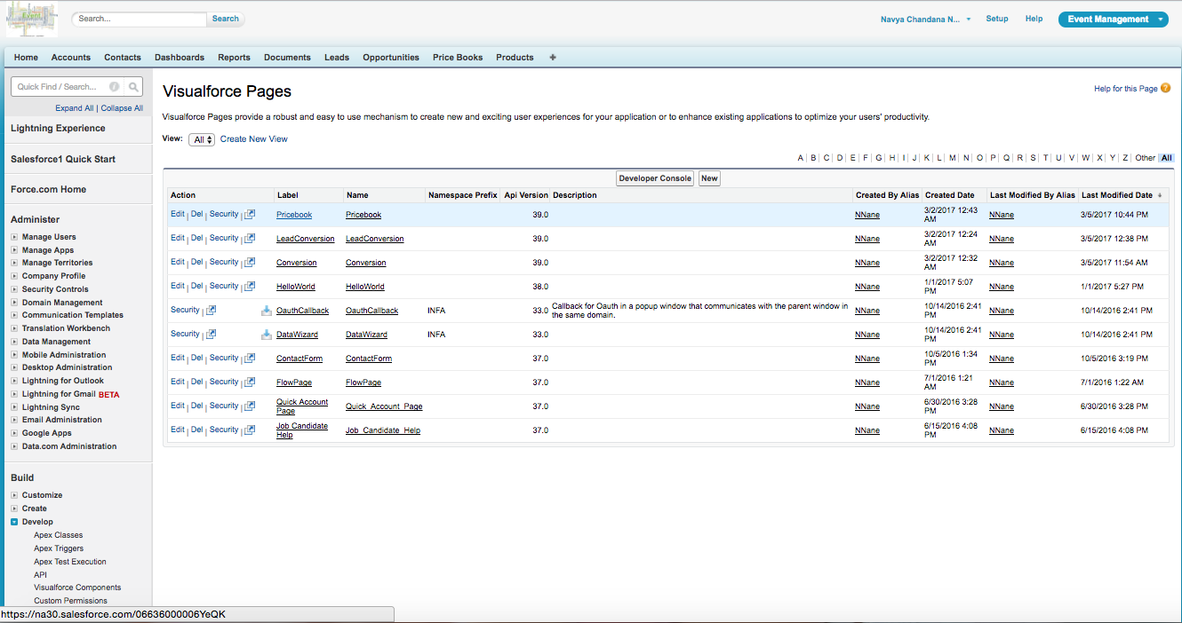

Step 10 : Pricebook.vfp page appears. Click on Preview

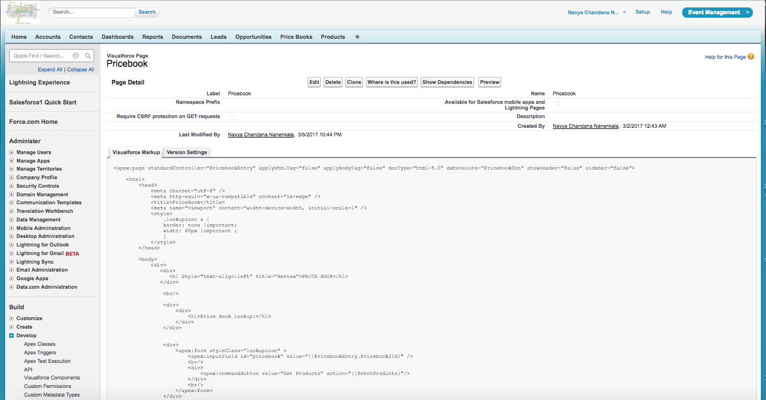

Step 11 : This page appears

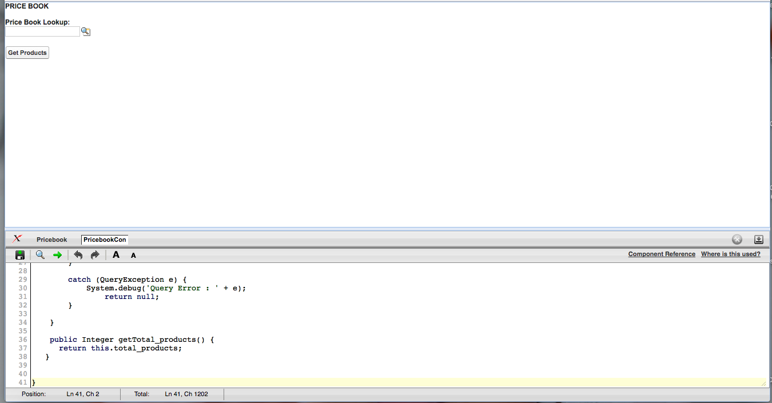

Step 12 : Click on Search button

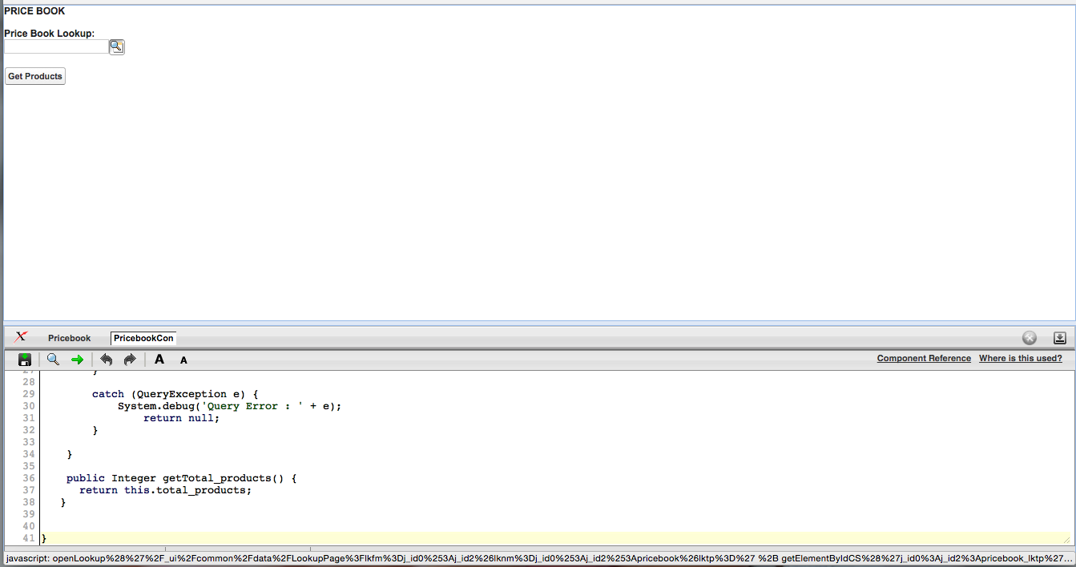

Step 13 : When we click on search button this page appears. Select one Price Book

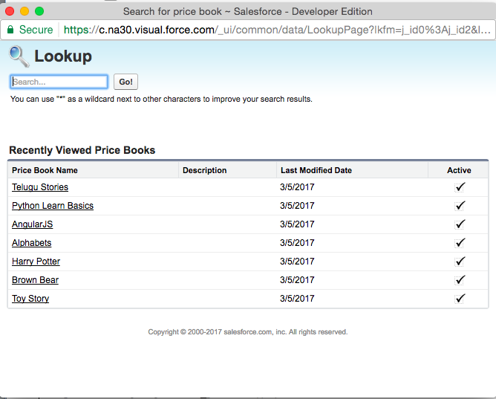

Step 14 : Click on get Products

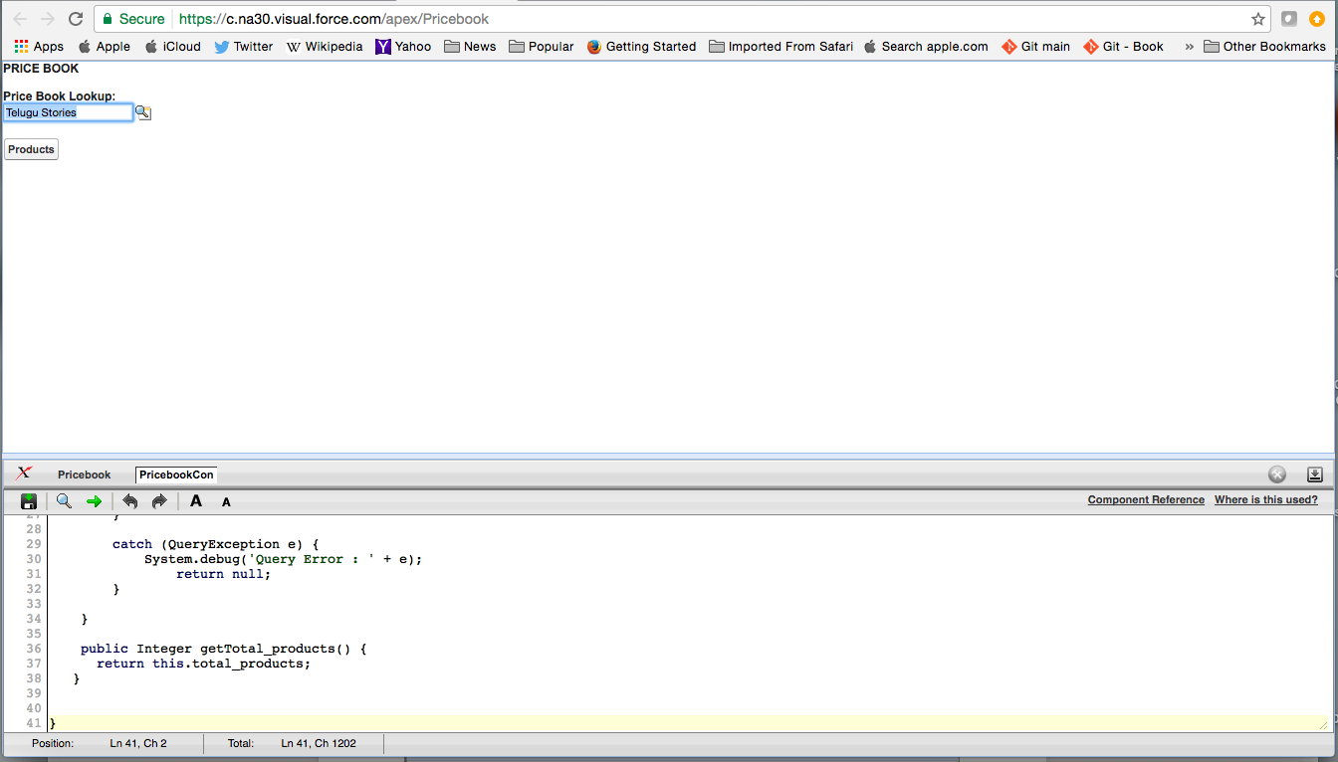

Step 15 : It shows the products list

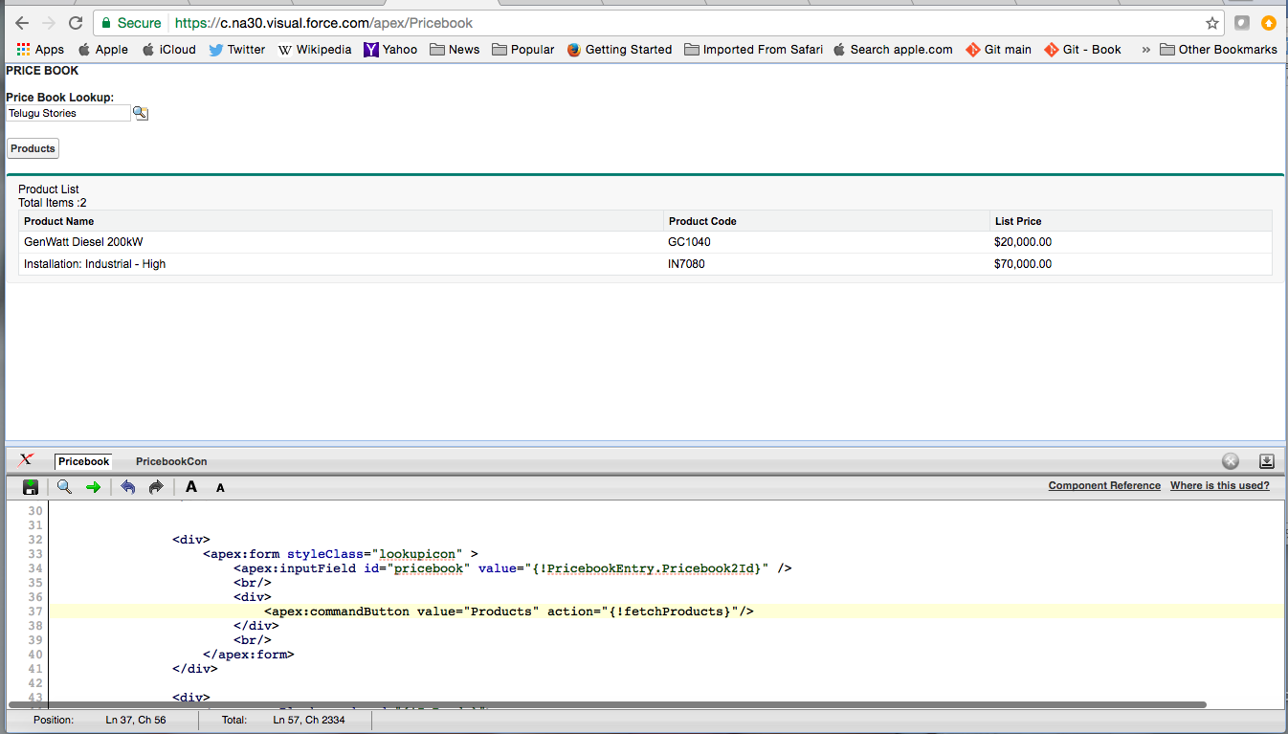

Pricebook Visualforce Page (Pricebook.vfp)

<apex:page standardController="PricebookEntry" applyHtmlTag="false" applyBodyTag="false" docType="html-5.0" extensions="PricebookCon" showHeader="false" sidebar="false">

<html>

<head>

<meta charset="utf-8" />

<meta http-equiv="x-ua-compatible" content="ie=edge" />

<title>PriceBook</title>

<meta name="viewport" content="width=device-width, initial-scale=1" />

<style>

.lookupicon a {

border: none !important;

width: 60px !important ;

}

</style>

</head>

<body>

<div>

<div>

<h1 Style="text-align:left" title="Review">PRICE BOOK</h1>

</div>

<br/>

<div>

<div>

<h1>Price Book Lookup:</h1>

</div>

</div>

<div>

<apex:form styleClass="lookupicon" >

<apex:inputField id="pricebook" value="{!PricebookEntry.Pricebook2Id}" />

<br/>

<div>

<apex:commandButton value="Products" action="{!fetchProducts}"/>

</div>

<br/>

</apex:form>

</div>

<div>

<apex:pageBlock rendered="{!IsReady}">

<div>Product List</div>

<apex:outputText value="{!Total_products}"> Total Items : </apex:outputText>

<apex:pageBlockTable value="{!ProductList}" var="product">

<apex:column value="{!product.Name}"/>

<apex:column value="{!product.ProductCode}"/>

<apex:column value="{!product.UnitPrice}"/>

</apex:pageBlockTable>

</apex:pageBlock>

</div>

</div>

</body>

</html>

</apex:page>

Pricebook.apxc(Controller Extension)

public class PricebookCon {

public List<PricebookEntry> productList = new List<PricebookEntry>();

public PricebookEntry entry;

public Boolean IsReady = false;

public integer total_products;

public PricebookCon(ApexPages.StandardController stdController) {

this.entry = (PricebookEntry)stdController.getRecord();

}

public PageReference fetchProducts(){

this.isReady = true;

System.debug( 'Pricebook id: ' + entry.Pricebook2Id );

return new PageReference(ApexPages.currentPage().getUrl() + '?' +'id='+ entry.Pricebook2Id);

}

public Boolean getIsReady(){

return this.IsReady;

}

public List<PricebookEntry> getProductList(){

try{

this.productList = [select Name, Product2Id, ProductCode, UnitPrice from PricebookEntry WHERE Pricebook2Id = :this.entry.Pricebook2Id];

this.total_products = productList.size();

return this.productList;

}

catch (QueryException e) {

System.debug('Query Error : ' + e);

return null;

}

}

public Integer getTotal_products() {

return this.total_products;

}

}